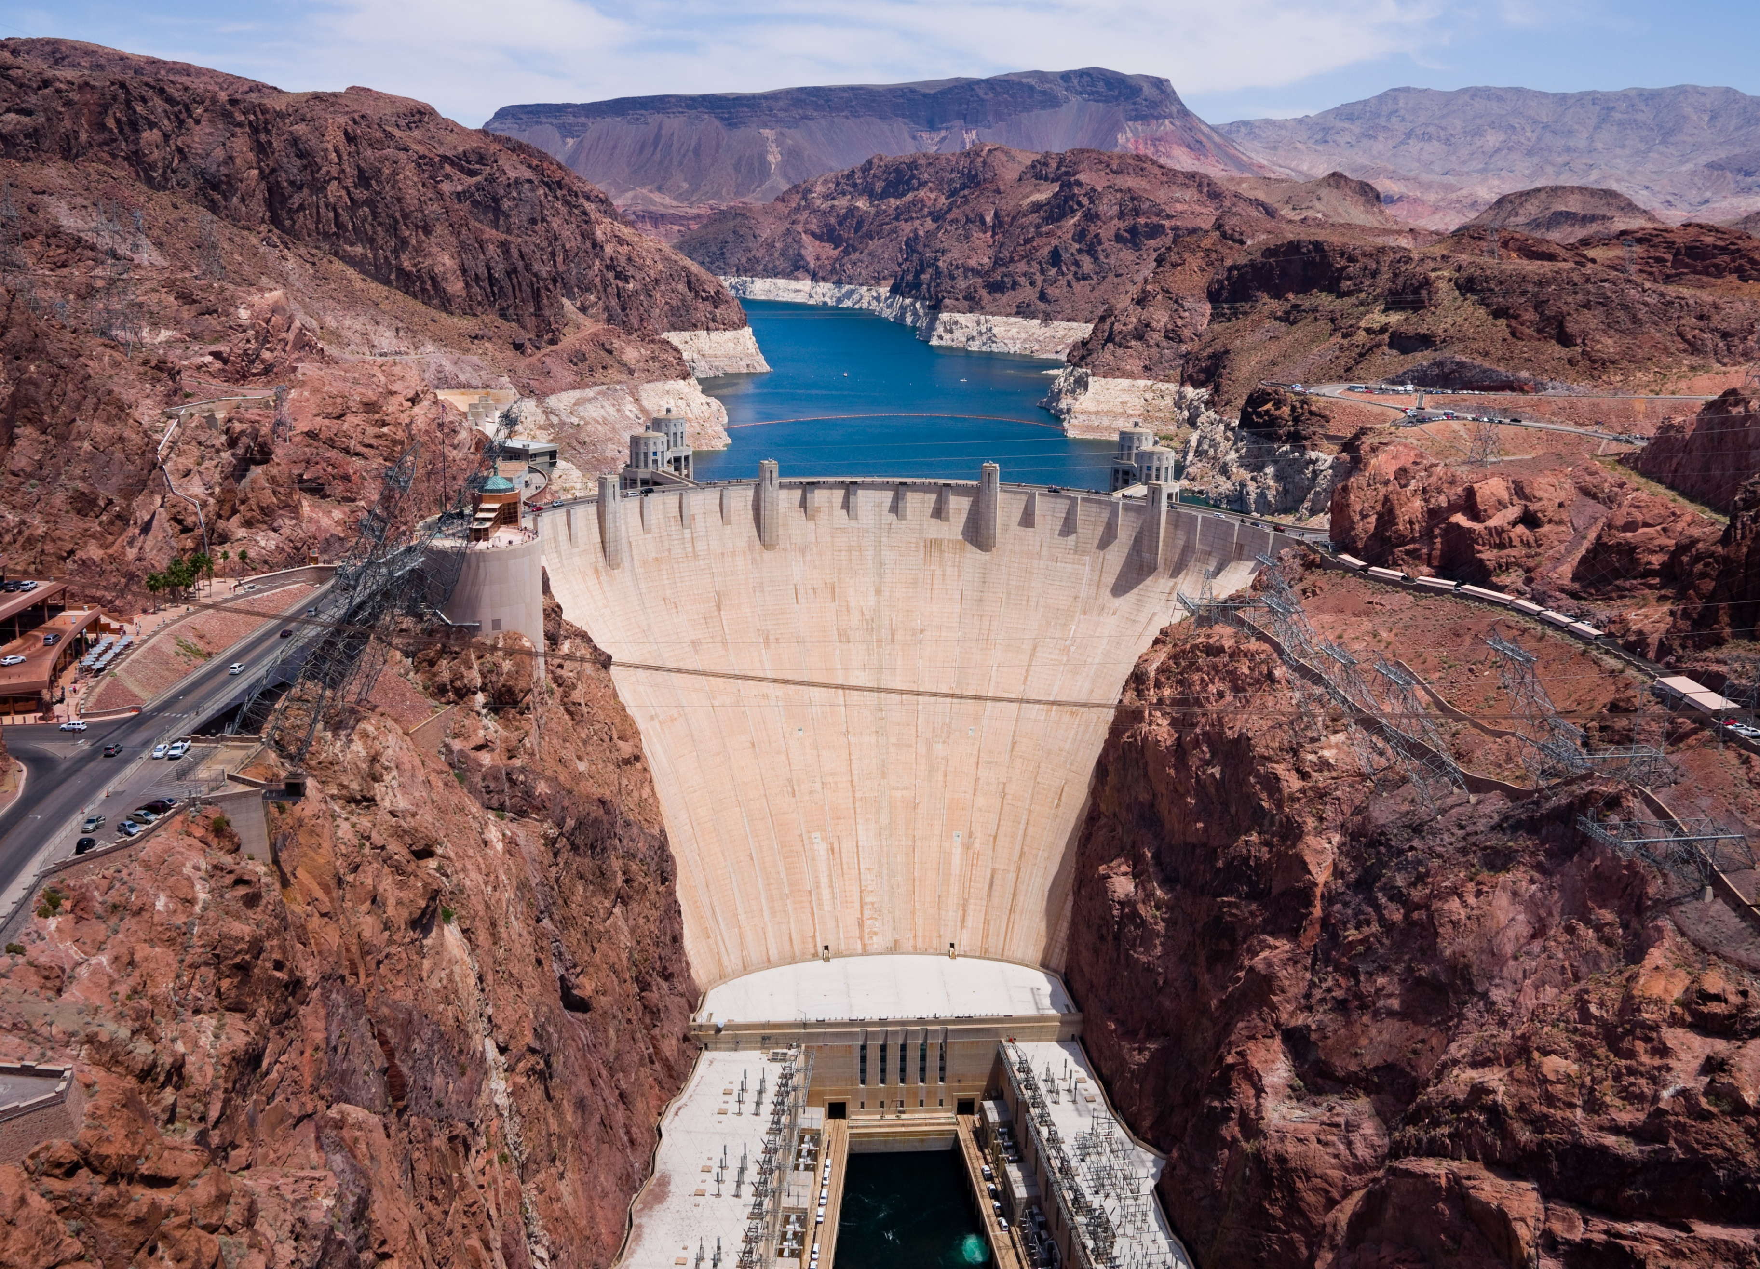

Homework 4
Reservoir Benefit Maximization in
General Algebraic Modeling System (GAMS)

Talha Quddoos- A02469393
Dr. David E. Rosenberg
CEE 6410- Civil Engineering Systems Analysis in the Age of Uncertainty
October 05, 2026

Introduction
A reservoir serves as a supply of water to a hydropower turbine, to a river, and to an irrigation area. The water from spillway as well as from the hydropower turbines can be used for irrigation. The supply distribution is to be decided for a period of 6 months in such a way that a maximum benefit (profit) from the reservoir water is obtained while staying under the capacity constraints and storage goals.

Model Formulation
The available information is represented in the form of a table 1.
Table 1 Water benefit problem summary
Month | Inflow Units | Hydropower Benefits($/unit) | Irrigation Benefits ($/unit)
1 | 2 | 1.6 | 1
2 | 2 | 1.7 | 1.2
3 | 3 | 1.8 | 1.9
4 | 4 | 1.9 | 2
5 | 3 | 2 | 2.2
6 | 2 | 2 | 2.2
In the given problem, we must maximize the water associated benefits by computing the units of water to be allocated for each demand site from water reservoir while staying under the resource constraints. The dimensions are 1. i.e the time [6months. Decision variables are the units of water to allocate to each demand site. The initial storage limits, turbine water holding capacity, reservoir water holding capacity, minimum units of water in the river and final storage units of water at the end are the constraints. The given information can be written in the form of objective function and resource constraints as below.
$$Obj: Max \sum_{month=1}^{6}{\left(\left(Hydropower Benefits×Water used by Turbine\right)+(Irrigation Benefits×Water Used by Irrigation)\right)}$$
Subject to (Constraints)
$${Storage}_{month1}=Initial Storage+{Inflow}_{month1}-{Water through Turbine}_{month1}-{Water Spilled}_{month1}$$
$${Storage}_{month(t)}={Storage}_{month(t-1)}+{Inflow}_{month(t)}-{Water through Turbine}_{month(t)}-{Water Spilled}_{month(t)}$$
$${Water used by reservoir }_{month(t)}≤9$$
$${Water used by Turbine }_{month(t)}≤4$$
$$Initial Storage=5$$
$$Water at {A }_{month(t)}≥1$$
$${Storage }_{month(6)}≥{Storage }_{month(1)}$$
Where, Storage, Water used by Turbine, Water used by irrigation, water inflow at A $≥0$

Conclusion and Recommendations
Solving the water distribution model in GAMS, we found a total benefit $51.6 for a period of six months. Optimum usage for turbine was found to be (1,1,2,4,4,4) units, and for irrigation it was found to be (0,0,1,3,3,3) units for six months. The reservoir capacity as well as inflow at A have no effect on the benefits; increasing it won't change anything. Irrigation, in first 2 months have negative marginal values; any additional unit towards irrigation would have resulted in a decrease in the profit, however for all the remaining months it doesn’t impact the profit. The negative marginal values for all months indicate that any increase in stream flow requirement at A will have a negative impact on the benefits. The addition of months will lead to the complexity of the model as it will include more data in the model and more seasonal complexities, moreover, the inflow to the reservoir may also change and the water requirements for irrigation may also change based on seasons including more constraints in the model making it complex.
Use of Artificial Intelligence (AI) & Github
No AI was used in the analysis or writeup.

References
GAMS Development Corporation. General Algebraic Modeling System (GAMS) Release: 54.4.0 , Fairfax, VA, USA, 2026 .
Quddoos (2025). "GAMS Solution for Hydropower-Irrigation Reservoir Optimization Problem." https://github.com/talha-q/CEE6410-Engineering-Systems
Category  (Max. Score) | No Evidence | Doesn’t Meet Standard | Nearly Meets Standard | Meets Standard | Exceeds Standard | Self- Score | Instructor Score
Title  (1) | Absent  0 | Evidence of two or less  0 | Evidence of three  0 | Evidence of four  1 | Title – can assess main point from title alone; Name, Instructors’ Names, Course, Date, Neatly finished 1 | 1
Introduction  (3) | Absent, no evidence  0 | There is no clear introduction or main topic.  1 | Introduction states the main topic but either:  - Does not give a full overview, Or:  - Too detailed, leading to annoying repetition later. 2 | The introduction states the main topic and previews the structure of the report.  2 | The introduction states the main topic and previews the structure of the report. Good overview of the problem and solution approach. Gives enough detail to motivate the reader to continue reading.  3 | 3
Organization and structural development of the idea: procedure, results, conclusions  (10) | No content provided.  0 | Paragraphs fail to develop the main idea. No section headers or guide to help the reader understand how material is organized.  1 – 5 | Organization of ideas not fully developed. Paragraphs lack supporting detail sentences. No transitions and/or ineffective section headers.  6 - 7 | Paragraph development present but not perfected. Each paragraph has sufficient supporting detail sentences. Few transitions.  8 | Writer demonstrates logic and sequencing of ideas through well-developed section headers, paragraphs, and transitions. The first sentence of each paragraph is the summary sentence.  9 - 10 | 8
Technical Correctness  (70) | Questions not addressed.  3 – 42% | The writer has no clue what they are talking about.  45 – 58% | Sketchy: left out required design points. Did not work on this as much as you should have, and it shows. Many important answers are incorrect.  61 – 79% | Discussion lacks adequate detail, but all the necessary points are covered and nearly all answers are correct.  82 – 88% | Provides what was explicitly asked for. The function of each piece is demonstrated to the reader in adequate, but not overwhelming, detail. Answers are correct and reasonable.  91 – 100%
Technical Correctness  (70) | - Problem formulation (15) and solution (10) |  |  |  |  | 25
Technical Correctness  (70) | - Sensitivity of net benefits (25) |  |  |  |  | 25
Technical Correctness  (70) | - Allowable increase of in-stream flow requirement (5) |  |  |  |  | 5
Technical Correctness  (70) | - Manager concerns as model time period increases (5) |  |  |  |  | 5
Technical Correctness  (70) | - New insights gained from modeling work (10) |  |  |  |  | 8
Technical Correctness  (70) | - Provide a link to your GAMS code on Github (0)

Category  (Max. Score) | No Evidence | Doesn’t Meet Standard | Nearly Meets Standard | Meets Standard | Exceeds Standard | Self- Score | Instructor Score
Word Usage and Format  (7) | Not applicable | Numerous and distracting errors in punctuation, capitalization, spelling, sentence structure, word usage, significant figures, tables, and figures. Data vomited onto page(s). Unacceptable / unprofessional at the graduate level. 1 – 5 | Misspelled words, poor English grammar and word choice. Main body of report is either longer or significantly less than one page. Figures are too small and/or under-labeled, although they are usually of acceptable quality and focus. Tables incoherent or not cohesive. Bad font sizes. Too much or too little data in appendices. Could be improved by being more meticulous.  5 | Almost no errors in punctuation, capitalization, spelling, sentence structure, word usage, significant figures, and presentation of figures, tables, and appendices. Main body of report is one page or less  6 | Punctuation, capitalization, spelling, sentence structure, word usage, and significant figures all correct. Main body of report is one page or less. Clear, consistent fonts. Good word processing skills. Figures have adequate contrast. Informative figure and table titles and legends. Figures have appropriate axis tick spacing, labels, units, and legends. Table columns cohesive, labeled, and specify units. Document is stapled. Appendices, if provided, are separated by topic, and each have a title, discussion, and proper formatting and display of information 7 | 6
Conclusion  (4) | Absent  0 | Incomplete and/or not focused. 1 | The conclusion does not adequately restate the main results. 2 | The conclusion restates the main results. 3 | The conclusion restates the main results, and is an effective summary. 4 | 4
Use of AI  (3) | Absent  (Return without grade) |  |  | See Policy on Use in Syllabus  If used, list the AI tool], provide a short description of use, how use is within the course policy, and link to the transcript of student-AI interactions.  If not used, write “No AI was used in the analysis or write-up of this report.” 3 |  | 3
References  (2) | Absent  0 | Numerous errors, off-the-wall sources used. 0 | Some errors in citing format; more sources should be cited. 1 | Prior work cited with few errors.  2 | All prior work and data sources are cited in the correct format with no errors. 2 | 2
TOTAL (100) |  |  |  |  |  | 94

